Topics:
- Many to Many Mapping

One to One Mapping:
This is the case when a user can have multiple vehicle; also one vehicle can have multiple user. In this case the relation is denoted by as follows:
In UserDetail entity:
@ManyToMany(cascade=CascadeType.PERSIST)
private List<Vehicle> vehicleList = new ArrayList<Vehicle>();

In Vehicle entity:
@ManyToMany
private List<UserDetail> vehicleUsers= new ArrayList<UserDetail>();
The persisting method looks like this:
List<UserDetail> userList = new ArrayList<UserDetail>();
List<Vehicle> vehicleList = new ArrayList<Vehicle>();
UserDetail user1 = new UserDetail("user1");
UserDetail user2 = new UserDetail("user2");
UserDetail user3 = new UserDetail("user3");
Vehicle vehicle1 = new Vehicle("Honda");
Vehicle vehicle2 = new Vehicle("Ford");
Vehicle vehicle3 = new Vehicle("Suzuki");
user1.getVehicleList().add(vehicle1);
user1.getVehicleList().add(vehicle2);
user2.getVehicleList().add(vehicle2);
user2.getVehicleList().add(vehicle3);
user3.getVehicleList().add(vehicle3);
user3.getVehicleList().add(vehicle1);
vehicle1.getVehicleUsers().add(user1);
vehicle1.getVehicleUsers().add(user3);
vehicle2.getVehicleUsers().add(user1);
vehicle2.getVehicleUsers().add(user2);
vehicle3.getVehicleUsers().add(user2);
vehicle3.getVehicleUsers().add(user3);
userList.add(user1);
userList.add(user2);
userList.add(user3);
for(UserDetail user : userList){
session.persist(user);
}

When the persist method executes, four table gets created:
- The table USER_DETAIL that contains the userId and username.
- The table VEHICLE_DETAIL that contains the vehicleId and vehicleModel.
- The table USER_DETAIL_VEHICLE_DETAIL that contain the relationship from user to vehicle.
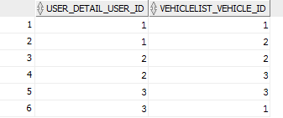
- The table VEHICLE_DETAIL_USER_DETAIL that contains the relationship from vehicle to user.
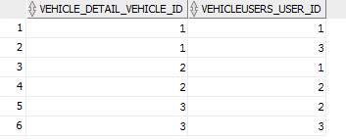
This mapping is redundant. Hence we need to configure the entities in such a way that only one mapping is created- we will consider from User to Vehicle. To do that, we will mark the vehicleUsers list in Vehicle entity as
@ManyToMany(mappedBy="vehicleList")
Where “vehicleList” is the list name in the UserDetail class.
The @JoinTable annotation will be written in the vehicleList variable in the UserDetail entity.
@ManyToMany(cascade=CascadeType.PERSIST)
@JoinTable(name="USER_VEHICLE_MAPPER", joinColumns=@JoinColumn(name="USER_IDENTITY"),InverseJoinColumns=@JoinColumn(name="VEHICLE_IDENTITY"))
private List<Vehicle> vehicleList = new ArrayList<Vehicle>();
This would define the name of the mapping table and the mapping columns.

